Kara Blakley

TOULOUSE-LAUTREC, HENRI DE (b. 1864, Alba - d.1901, Gironde)

Few names are as synonymous with the freethinking associated with the French avant-garde as Henri de Toulouse-Lautrec. Born into an aristocratic family, Toulouse-Lautrec chose to spend much of his working life in bohemian Montmartre, which would influence his modernist artistic tendencies. Toulouse-Lautrec chose to reject the academic-style in which he was trained; favouring scenes of night clubs and theatres to grand histories and mythology, he helped liberate painting from what was considered acceptable subject matter. Furthermore, Toulouse-Lautrec employed prominent lines, flattened surfaces, and ghoulish colours, which would become hallmarks of later modernist painters. Toulouse-Lautrec frequently worked in oils, watercolour, charcoal, pastel, ink, and coloured pencils, but was open to using any technique that allowed him to achieve his artistic goals; this openness allowed him to create not only paintings, but lithographs, posters, and commercial prints, thus further expanding the media and methods available to avant-garde artists. Perhaps owing to the fact that he was ostracised from elite society because of his physical disabilities, extravagant self-characterisation, and underclass acquaintances, Toulouse-Lautrec became masterful at depicting psychological authenticity and revealing innate social hypocrisies in bourgeois social practices. Although his career was cut short due to his untimely death, Toulouse-Lautrec helped provide the blueprints for later modernist painting.

Born to first-cousin parents, young Henri demonstrated both early signs of genetic maladies and artistic aptitude. In 1882, Toulouse-Lautrec was afforded the opportunity to study under the tutelage of Léon Bonnat, whose studio (which functioned as an art school), was among the most acclaimed at the time. Between 1882 and 1885, Toulouse-Lautrec began to forge his own style upon discovering the schism between official art, such as that of Bonnat, and the newly-emerging avant-garde artists such as the Impressionist group who first exhibited collectively in 1874. Facilitating his immersion in the avant-garde movement was his relocation to Montmartre in 1885. Here, he was free to explore two components which would become associated with his œuvre: distorted, caricaturising lighting and scenes of the Parisian social underworld. Toulouse-Lautrec observed the former while at theatres, where contemporary stage lighting—footlighting—illuminated actors from below, casting unflattering and exaggerated shadows. The former, scenes in brothels, night clubs, bars, circuses, etc., are now instantly attributable to Toulouse-Lautrec upon first glance. In particular, his interest in dance hall scenes coincided with the opening of the famous Moulin Rouge in 1889; here, Toulouse-Lautrec could mingle with entertainers and aristocrats alike, a nod to the class ambiguity in which he indulged throughout his artistic career. His relationship with the women in his life exemplify a microcosm of this class ambiguity: he maintained contact with his mother, an aristocrat, almost daily; in 1889, he fell in love with Suzanne Valadon, who was born into poverty and worked as a trapeze artist; and finally, while at the Moulin Rouge, he became a long-term friend of Louise Weber, or “La Goulue”, a famous performer who became one of the artist’s muses and models. He later became acquainted with the dancer Jane Avril, a recognisable figure in many of Toulouse-Lautrec’s prints and paintings. Among his masterpieces, AT THE MOULIN ROUGE (1892-1895) demonstrates the artist’s penchant for ghoulish colours and prominent lines. By the mid-1890s, his alcoholism and erratic behaviour became increasingly problematic, and in 1899, he was institutionalised briefly; in 1901, Henri de Toulouse-Lautrec suffered a fatal stroke and passed away at Chateau de Malrome, his mother’s home shortly thereafter.

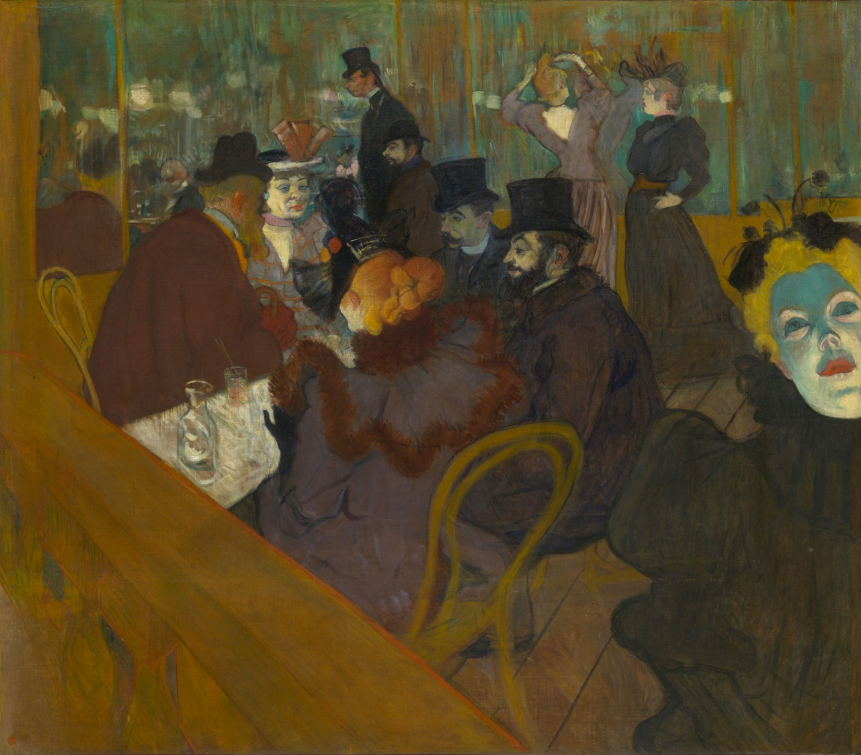

AT THE MOULIN ROUGE (1892-1895)

<http://en.wikipedia.org/wiki/At_the_Moulin_Rouge>

References and further reading:

<http://www.toulouse-lautrec-foundation.org/>

Chapin, Mary Weaver, *Henri de Toulouse-Lautrec and the café-concert: printmaking, publicity, and celebrity in fin-de-siecle Paris*. Ann Arbor, MI: UMI, 2002.

Eisenman, Stephan, *Nineteenth-Century Art: a critical history*. New York, NY: Thames & Hudson, 2002.

Gerhard, Gruitrooy, *Henri de Toulouse-Lautrec*. New York, NY: Smithmark, 1996.

Frèches, Claire, *Toulouse-Lautrec: scenes of the night*. Trans. Alexandra Campbell. New York: Harry N. Abrams, 1994.

Mack, Gerstle, *Toulouse-Lautrec*. New York: Paragon House, 1989.